# Reddit API:

<https://github.com/praw-dev/praw>

* Public API, python wrapper called PRAW (python reddit api wrapper)
* Can pull top comments, hot posts, etc
* PRAW aims to be easy to use and internally follows all of [Reddit's API rules](https://github.com/reddit/reddit/wiki/API). (Thank fook)
* With PRAW there's no need to introduce **sleep calls** in your code. Give your client an appropriate user agent and you're set.

Set up:

* PRAW is supported on python 2.7, 3.3, 3.4, 3.5 and 3.6. The recommended way to install PRAW is via [pip](https://pypi.python.org/pypi/pip).
* PRAW Documentation <https://praw.readthedocs.io/en/latest/>

Subreddits:

* [/r/redditdev](https://www.reddit.com/r/redditdev) is the best place on Reddit to ask PRAW related questions. This subreddit is for all Reddit API related discussion so please tag submissions with [PRAW]. Please perform a search on the subreddit first to see if anyone has similar questions.
* r/CryptoCurrency – 870,000 members
* r/Bitcoin – 1,000,000 members

## PRAW Documentation and set up

PRAW Documentation <https://praw.readthedocs.io/en/latest/>

# Authenticating via OAuth

All info is here <https://praw.readthedocs.io/en/latest/getting_started/authentication.html>

PRAW supports the three types of applications that can be registered on Reddit. Those are:

* [Web Applications](https://github.com/reddit-archive/reddit/wiki/OAuth2-App-Types#web-app)
* [Installed Applications](https://github.com/reddit-archive/reddit/wiki/OAuth2-App-Types#installed-app)
* [Script Applications](https://github.com/reddit-archive/reddit/wiki/OAuth2-App-Types#script-app)

The app types are explained here: <https://github.com/reddit-archive/reddit/wiki/OAuth2-App-Types#web-app>

Use <http://localhost:8080> for the redirect uri

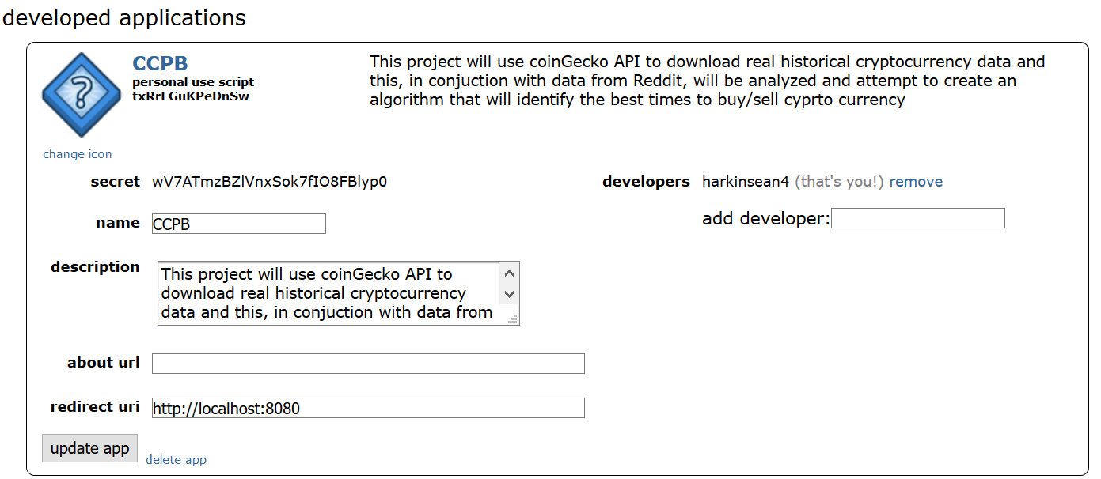

**Client ID & Client Secret:**

These two values are needed to access Reddit’s API as a **script** application (see [Authenticating via OAuth](https://praw.readthedocs.io/en/latest/getting_started/authentication.html#oauth) for other application types). If you don’t already have a client ID and client secret, follow Reddit’s [First Steps Guide](https://github.com/reddit/reddit/wiki/OAuth2-Quick-Start-Example#first-steps) to create them.

**User Agent:**

A user agent is a unique identifier that helps Reddit determine the source of network requests. To use Reddit’s API, you need a unique and descriptive user agent. The recommended format is

<platform>:<app ID>:<version string> (by /u/<Reddit username>). For example,android:com.example.myredditapp:v1.2.3 (by /u/kemitche). Read more about user-agents at [Reddit’s API wiki page](https://github.com/reddit/reddit/wiki/API).

## REDDIT API Rules

<https://github.com/reddit-archive/reddit/wiki/API>

sean_script_application.py

The parent.id() will retrieve the thread/submission id

The .list() is a PRAW functionality, it returns a flattened list of all Comments. This list may contain MoreComments instances if replace_more() was not called first.

.replace_more(limit=0) we set the limit to 0 to remove all [MoreComments](https://praw.readthedocs.io/en/latest/code_overview/models/more.html#praw.models.MoreComments) instances without additional requests

on really long comments, there will be a ‘load more comments’ link which is a ‘more_comments’ object, so we won’t to replace these ‘more_comments’ objects